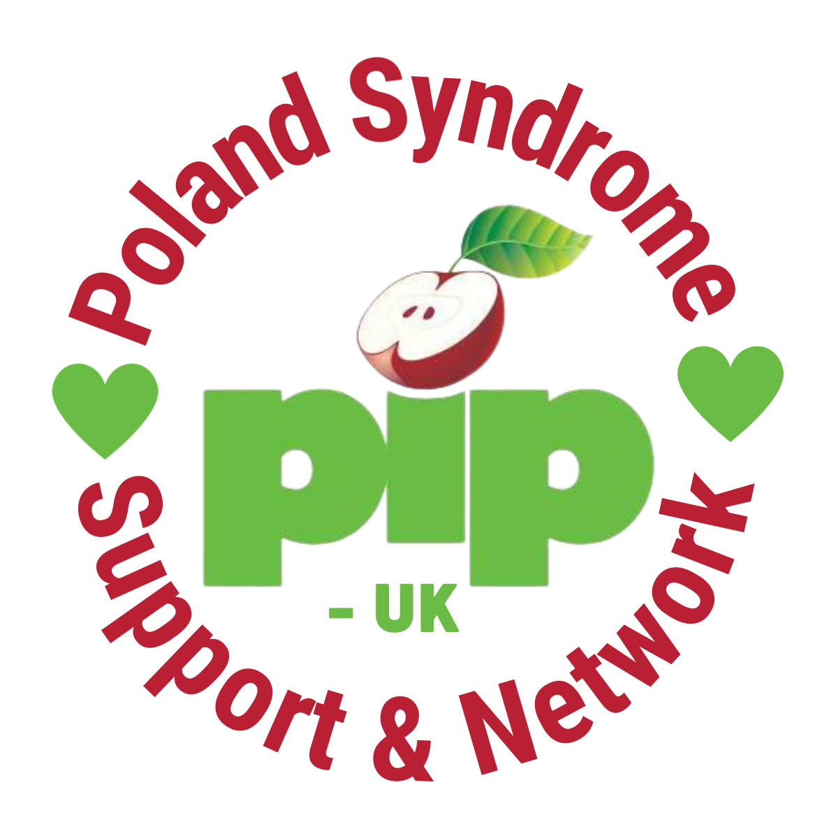
Role description - Trustee
Overall purpose
The Board of Trustees are responsible for the overall governance and strategic direction of the charity, developing the organisation’s aims, objectives and goals in accordance with the governing document, legal and regulatory guidelines.

Main responsibilities
- To ensure that the charity and its representatives function within the legal and regulatory framework of the sector and in line with the organisation’s governing document, continually striving for best practice in governance.

- To determine the overall direction and development of the charity through good governance and clear strategic planning.

- To carry out trustee board duties inline with the Nolan Principles: selflessness, integrity, objectivity, accountability, openness, honesty, and leadership.

Main duties
- Ensuring the charity complies with legislative and regulatory requirements and acts within the confines of its governing document and in furtherance to organisational activities contained therein.

- Acting in the best interest of the charity, beneficiaries and future beneficiaries at all times.

- Promoting and developing the charity in order for it to grow and maintain its relevance to the Poland Syndrome Community.

- Ensuring effective and inclusive engagement with all parts of the community.

- Maintaining sound financial management of the charity’s resources, ensuring expenditure is in line with the organisation’s objectives, and investment activities meet accepted standards and policies.

- Interviewing, appointing and monitoring the work and activities of the senior paid staff.

- Ensuring the effective and efficient administration of the charity and its resources in some cases, acting as a counter-signatory on charity finances and any applications for funds.

- To maintain absolute confidentiality about all sensitive/confidential information received in the course of trustees’ responsibilities to the charity.

Accountable to
The board members are responsible and liable for the governance and functioning of the charity. Close attention must be given to the governing document to ascertain the type of organisational structure and the range of interested parties.

What difference will you make?

You will have a direct impact on how PIP-UK is governed and functions. You will play a key part alongside PIP-UKs members, volunteers & CEO to decide the vision of the organisation. Ensuring we stay on track and meet our overall aims to improve the diagnosis, treatment, support and connections for our Poland Syndrome Community.

What are we looking for?

Previous board experience is not essential.

Enthusiasm to support the organisation deliver on our vision mission and values are essential, together with an understanding of or willingness to learn about good charitable governance.

We are a diverse and inclusive organisation and we particularly welcome applications from black, asian and ethnic minority people along with applications from young people and people with disabilities.

All members of the board will:

- Commit to the aims, principles and direction of PIP-UK
- Have lived experience of Poland Syndrome as a patient or family member/friend/supporter of the community
- Have a demonstrable understanding of the third sector and commitment to its development
- Not represent individuals, organisations, specific client groups, or self-interests on the board
- Not be employed by a ‘statutory organisation’ or other agency which could create a conflict of interest

We are looking to bring six new people onto the trustee board, two or more of which will have specific experience in either:

- Volunteer Management
- Finance Skills
- Marketing and digital communication; or
- Income generation through fundraising and corporate donations
- Medical/Scientific or Research knowledge

Where and When

Remotely

Mostly during office hours

Estimate of time needed:
7-15 hours per month

Details on how to apply

To apply, please send an up-to-date CV to pip.charity@gmail.com by midnight on Sunday 4th September.

You are really welcome to reach out for an informal chat about the role, please email sam,pipuk@gmail.com or call Sam on 07877 664 170.

