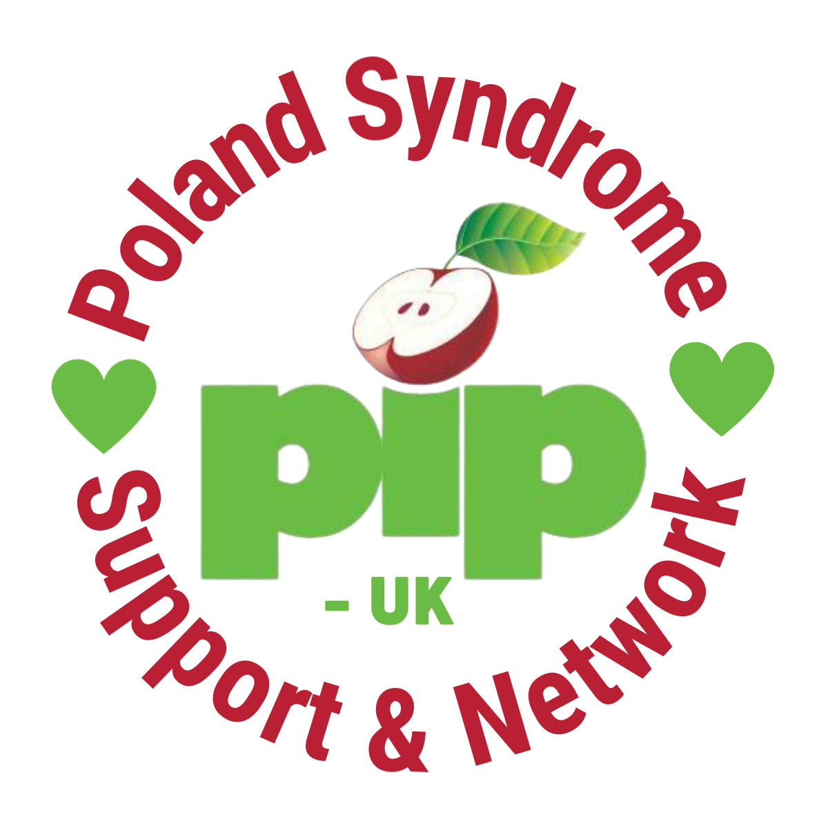
Make a difference - join our board

PIP-UK is looking to recruit six new trustees to help turn our new vision into reality.

We are on our way to creating a thriving Poland Syndrome Community that enables the people affected by Poland Syndrome to live their best lives.

PIP-UK brings together the Poland Syndrome Community by creating a culture that celebrates, connects and informs. But we cannot achieve our goals alone.

Your role as a Trustee is to work with other Trustees as part of a team, providing leadership, strategic direction and collective responsibility for robust governance to ensure the charity is running effectively and efficiently and delivers benefit and value. All Trustees are volunteers and the positions are unremunerated.

We are looking to bring six new people onto the trustee board, two or more of which will have specific experience in either:

- Volunteer Management
- Finance Skills
- Marketing and digital communication; or
- Income generation through fundraising and corporate donations
- Medical/Scientific or Research knowledge

All members of the board will:
- Commit to the aims, principles and direction of PIP-UK
- Have lived experience of Poland Syndrome as a patient or family member/friend/supporter of the community
- Have a demonstrable understanding of the third sector and commitment to its development
- Not represent individuals, organisations, specific client groups, or self-interests on the board
- Not be employed by a ‘statutory organisation’ or other agency which could create a conflict of interest

Previous board experience is not essential. Enthusiasm to support the organisation deliver on our vision mission and values are essential, together with an understanding of or willingness to learn about good charitable governance.

We are a diverse and inclusive organisation and we particularly welcome applications from black, asian and ethnic minority people along with applications from young people and people with disabilities.

To apply, please send an up-to-date CV to pip.charity@gmail.com by midnight on Sunday 4th September.

You are really welcome to reach out for an informal chat about the role, please email sam,pipuk@gmail.com or call Sam on 07877 664 170.

